**Topics: Descriptive Statistics and Probability**

1. Look at the data given below. Plot the data, find the outliers and find out $μ, σ, σ^{2}$

|  |  |
| --- | --- |
| **Name of company** | **Measure X** |
| Allied Signal | 24.23% |
| Bankers Trust | 25.53% |
| General Mills | 25.41% |
| ITT Industries | 24.14% |
| J.P.Morgan & Co. | 29.62% |
| Lehman Brothers | 28.25% |
| Marriott | 25.81% |
| MCI | 24.39% |
| Merrill Lynch | 40.26% |
| Microsoft | 32.95% |
| Morgan Stanley | 91.36% |
| Sun Microsystems | 25.99% |
| Travelers | 39.42% |
| US Airways | 26.71% |
| Warner-Lambert | 35.00% |

Book1 <- read_excel("C:/Users/harsh/Desktop/Book1.xlsx")

View(Book1)

**BOXPLOT**

boxplot(Book1$`Measure X`)

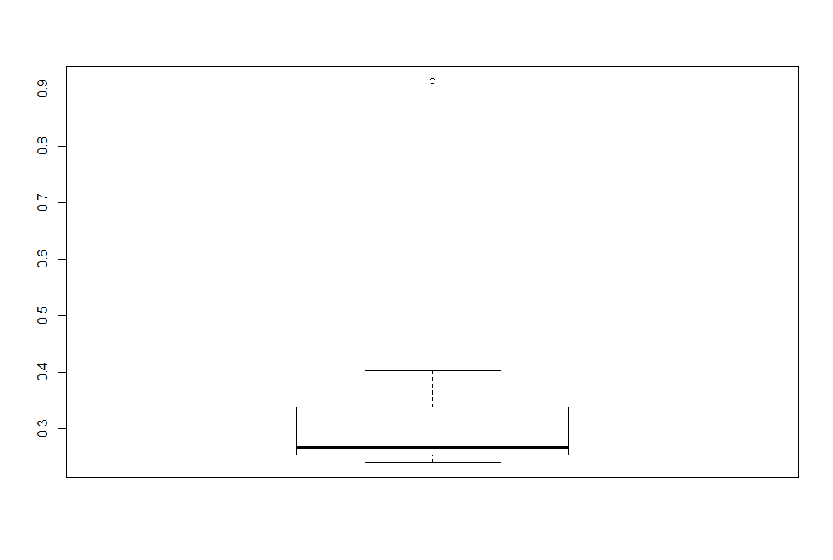

IT HAS MORE OUTLIERS TO UPPER AREA THAT IS MORGAN STANLEY 91.36%

**MEAN=**> mean(Book1$`Measure X`)

[1] 0.3327133

VARIENCE > var(Book1$`Measure X`)

[1] 0.02871466

> STANDARD DEVIATION > sd(Book1$`Measure X`)

[1] 0.169454



Answer the following three questions based on the box-plot above.

1. What is inter-quartile range of this dataset? (please approximate the numbers) In one line, explain what this value implies.

ANS :IQR= Q3-Q1

Q3=11

Q1=7

11-7=4

1. What can we say about the skewness of this dataset?

ANS = THE DATA IS RIGHTLY SKEWED OR POSTIVELY SKEWED

1. If it was found that the data point with the value 25 is actually 2.5, how would the new box-plot be affected?

ANS=OUTLIERS WILL BE REDUCED



Answer the following three questions based on the histogram above.

1. Where would the mode of this dataset lie?

ANS= as an assumption ew can say that the mode value will be between 4 to 8 values where is the highest 2 bars have.

1. Comment on the skewness of the dataset.

Ans=it is rightly skewed or +ve skewness

1. Suppose that the above histogram and the box-plot in question 2 are plotted for the same dataset. Explain how these graphs complement each other in providing information about any dataset.

Ans= both the plots have a postive skewness and we can see an outlier value on y axis that is 25.

1. AT&T was running commercials in 1990 aimed at luring back customers who had switched to one of the other long-distance phone service providers. One such commercial shows a businessman trying to reach Phoenix and mistakenly getting Fiji, where a half-naked native on a beach responds incomprehensibly in Polynesian. When asked about this advertisement, AT&T admitted that the portrayed incident did not actually take place but added that this was an enactment of something that “could happen.” Suppose that one in 200 long-distance telephone calls is misdirected. What is the probability that at least one in five attempted telephone calls reaches the wrong number? (Assume independence of attempts.)

LESS INFORMATION? GIVE HINT TO DO

1. Returns on a certain business venture, to the nearest $1,000, are known to follow the following probability distribution

|  |  |
| --- | --- |
| x | P(x) |
| -2,000 | 0.1 |
| -1,000 | 0.1 |
| 0 | 0.2 |
| 1000 | 0.2 |
| 2000 | 0.3 |
| 3000 | 0.1 |

1. What is the most likely monetary outcome of the business venture?

ANS- probability more on 2000 (0.3) which is highest compared to other values.by looking on probability of returns (0.2+0.3+0.1=0.6*100=60%) he has a chance getting succseful by longrun

1. Is the venture likely to be successful? Explain

YES,BY LOOKING ON PROBABILITY DISTRIBUTION THE VENTURE HAS POSTIVE CHANCE OF GETTING SUCCESFUL .

1. What is the long-term average earning of business ventures of this kind? Explain

Ans= The expected value of returns will be

(-2000*0.1)+(-1000*0.1)+(1000*0.2)+(2000*0.3)+(3000*0.1)=800

1. What is the good measure of the risk involved in a venture of this kind? Compute this measure

Ans= risk factor will vary with change in expected returns and it can be measured by std deviation and variance.